VENANGO TECHNOLOGY CENTER
JOINT COMMITTEE
1 Vo-Tech Drive
Oil City, Pennsylvania 16301

MINUTES

February 3, 2020

The regular meeting of the Venango Technology Center Joint Committee was held this evening in the Conference Room of the Venango Technology Center, 1 Vo-Tech Drive, Oil City, PA 16301. Mrs. Neely called the meeting to order at seven o’clock (7:00) p.m.

Mrs. Neely asked the members to pause for a moment of silence.

Mrs. Neely asked the members to stand for the pledge of allegiance.

Roll Call: Present: Todd Carson, James Come, James Disque, Misty Nalepa, Mark Marterella,
Shari Neely

Absent: Robert Blauser, Jeff Thomas, Don Judy, Troy Johnston

Also Present: Mr. Mario Fontanazza, Dr. Linda Weller

Mrs. Neely stated the Joint Committee members had received copies of the Minutes of the January 6, 2020 meeting in the mail. She asked if there were any additions, corrections or deletions.

Mr. Carson, seconded by Mr. Marterella, moved to approve the Minutes of the January 6, 2020 meeting as submitted.

Roll Call: Ayes: Todd Carson, James Come, James Disque, Misty Nalepa, Mark Marterella,
Shari Neely

Nayes: None, motion carried.

The Treasurer and Secretary’s Report as of 2/3/2020 Special Account report for 2/3/2020 were submitted for information.

Mr. Carson, seconded by Mr. Disque, moved to accept the Treasurer and Secretary’s Report and the Special Account report as of 2/3/2020 as submitted.

The motion was unanimously approved.

A list of bills from 1/7/2019 – 2/3/2020 in the amount of $605,893.57 was presented for approval.

Mr. Marterella, seconded by, Mr. Carson, moved to approve the list of bills as presented.

Roll Call: Ayes: Todd Carson, James Come, James Disque, Misty Nalepa, Mark Marterella,
Shari Neely

Nayes: None, motion carried.

Under Communications, Mr. Fontanazza discussed the Professional Advisory Committee minutes. He also discussed the Calendar of Events for the month of January and the Monthly Enrollment Report as of 2/3/2020 were submitted.

Mr. Judy arrived at 7:04 p.m.

Mrs. Neely requested approval of the action items as presented. Item 8. a) ii. –v. in one motion.

Mr. Carson, seconded by Ms. Nalepa, moved to approve action items 8. a) ii. –v. as follows:

    - Approve additions to the Occupational Advisory Committees. No additions
    - Accept successful bid on the sale of the modular home for $61,000.00 form Marshall Mansfield of Franklin, PA.
    - Approve resolution authorizing Shari Neely, Mark Marterella and Patrick Adams as the check signers for the payroll and General Fund accounts with Northwest Savings Bank and the General Fund PLGIT account.
    - Approve resolution adopting amendments to the Venango Technology Center 403b plan.
    - Approve Mario Fontanazza to attend the PA Association of School Administrators Leadership Forum on March 29-31, 2020 in Harrisburg at a cost not to exceed $1,100.00. Funding – Local
    - Approve Contract with Aegis Company for removal of Asbestos in summer of 2020.

Roll Call: Ayes: Todd Carson, James Come, James Disque, Misty Nalepa, Mark Marterella,
Shari Neely, Don Judy

Nayes: None, motion carried.

Mr. Fontanazza reviewed his Issues/Activities for January 2020.

Mr. Adams discussed the nature of the Personnel Committee. He asked if the most recent past members would like to continue to serve. He then discussed how the committee was most recently made up. He stated that usually it is current president, last president and next president. Since Mr. Marterella and Ms. Nalepa had recently served, he asked if they and Mrs. Neely would like to act as the current committee. They said they would. He indicated that the next personnel committee meeting would be at 6 p.m. on March 2nd, 2020 prior to the regular meeting.

Mrs. Neely asked if there was any old business.

None was noted.

Mrs. Neely asked if there was any new business.

None was noted.

Upon motion by Mr. Marterella, seconded by Mr. Carson, the meeting adjourned at twenty minutes past seven (7:20) p.m.

Recorded by
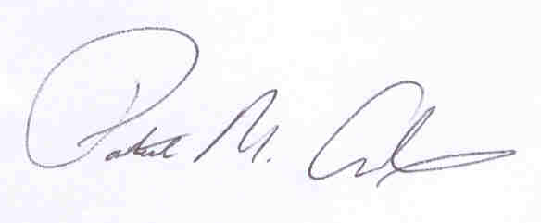
Patrick M. Adams
Secretary, Joint Committee

